Operating system project

**Name: ANKIT ANAND**

**Reg. No. : 11616235**

**Section : K1653**

**Roll-A 11**

**Email Id :** [**ankanand219@gmail.com**](mailto:ankanand219@gmail.com)

**GitHub Link:** [**https://github.com/ANKIT-ANAND/K1653_A11_ANKIT ANAND**](https://github.com/ANKIT-ANAND/K1653_A11_ANKIT%20ANANDP)

**Question No. : 22**

**Problem:**

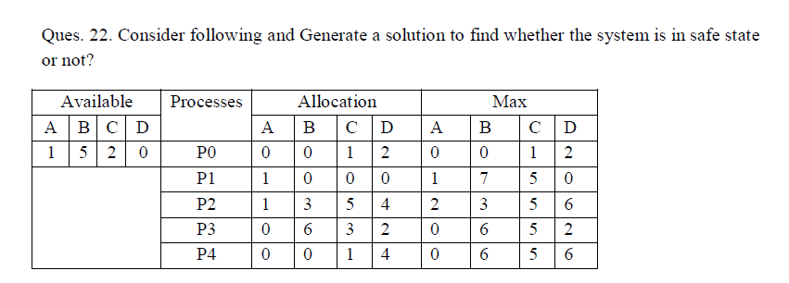

**ALGORITHM:**

**1) Let Work and Finish be vectors of length ‘m’ and ‘n’ respectively.**

**Initialize: Work = Available**

**Finish[i] = false; for i=1, 2, 3, 4….n**

**2) Find an i such that both**

**a) Finish[i] = false**

**b) Needi <= Work if no such i exists goto step (4)**

**3) Work = Work + Allocation**

**Finish[i] = true**

**goto step (2)**

**4) If finish [i] = true for all i**

**then the system is in a safe state**

**Time Complexity:**

O(n*n*m)

**CODE SNIPPET:**

